TASK 4:
#include <stdio.h>

int main() {
int a[3][3];
int i, j, upper = 1, lower = 1;

printf("Enter value of matrix:\n");
for(i=0; i<3; i++)
for(j=0; j<3; j++)
scanf("%d", &a[i][j]);

for(i=0; i<3; i++)
for(j=0; j<3; j++) {
if(i > j && a[i][j] != 0)
upper = 0;
if(i < j && a[i][j] != 0)
lower = 0;
}
if(upper == 1)
printf("\nMatrix is upper triangle :)\n");
else if(lower == 1)
printf("\nMatrix is lower triangle\n");
else
printf("\nMatrix is not any of them\n");

return 0;
}
OUTPUT:
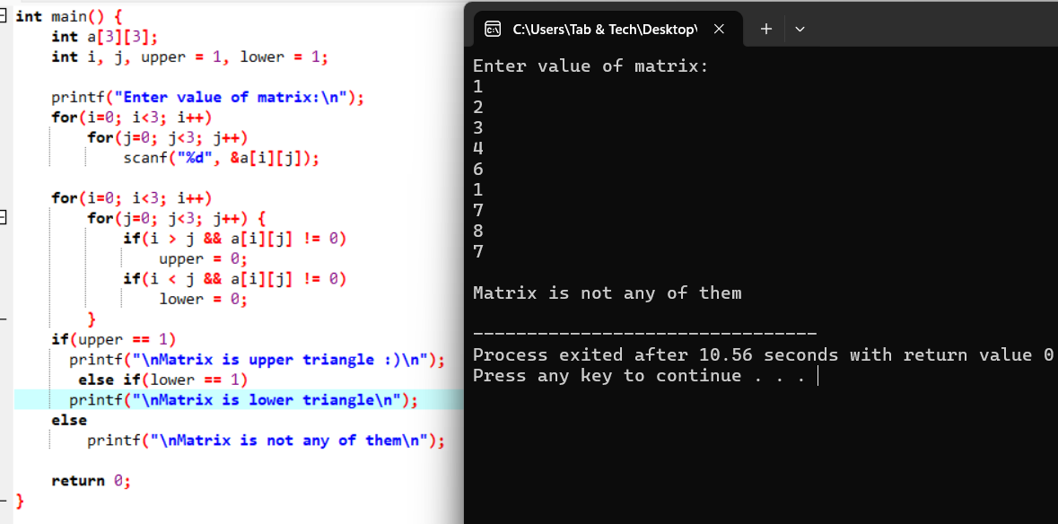

TASK 5:
#include <stdio.h>
int main() {
int n, i, j, space;
printf("Enter number of rows for half diamond: ");
scanf("%d", &n);

for(i=1; i<=n; i++) {
for(space=i; space<n; space++)
printf(" ");
for(j=1; j<=2*i-1; j++)
printf("*");
printf("\n");
}
for(i=n-1; i>=1; i--) {
for(space=n; space>i; space--)
printf(" ");
for(j=1; j<=2*i-1; j++)
printf("*");
printf("\n");
}
return 0;
}
OUTPUT:
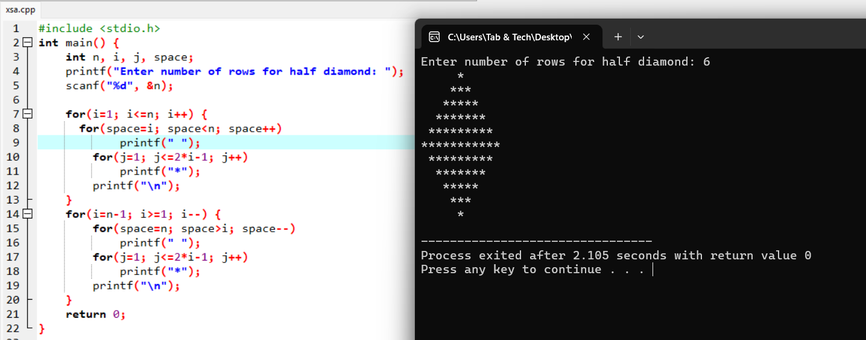

TASK 6:
#include <stdio.h>
int main() {
int a[3][3], t[3][3];
int i, j;
printf("Enter elements:\n");
for(i=0; i<3; i++)
for(j=0; j<3; j++)
scanf("%d", &a[i][j]);

for(i=0; i<3; i++)
for(j=0; j<3; j++)
t[j][i] = a[i][j];

printf("\nOriginal Matrix:\n");
for(i=0; i<3; i++) {
for(j=0; j<3; j++)
printf("%d ", a[i][j]);
printf("\n");
}
printf("\nTranspose Matrix:\n");
for(i=0; i<3; i++) {
for(j=0; j<3; j++)
printf("%d ", t[i][j]);
printf("\n");
}
return 0;
}
OUTPUT:
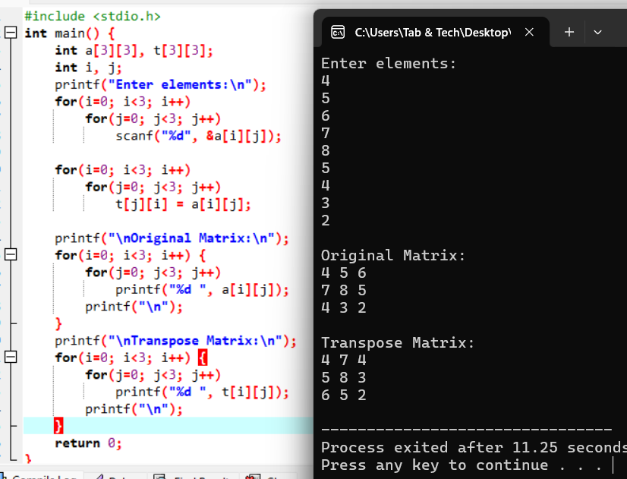

TASK 7:
#include <stdio.h>
int main() {
int n, i, j, k;
printf("Enter size of matrices: ");
scanf("%d", &n);

int A[3][3], B[3][3], M[3][3];

printf("Enter elements of first matrix:\n");
for(i=0; i<n; i++)
for(j=0; j<n; j++)
scanf("%d", &A[i][j]);

printf("Enter elements of second matrix:\n");
for(i=0; i<n; i++)
for(j=0; j<n; j++)
scanf("%d", &B[i][j]);

for(i=0; i<n; i++)
for(j=0; j<n; j++) {
M[i][j] = 0;
for(k=0; k<n; k++)
M[i][j] += A[i][k] * B[k][j];
}

printf("\nResultant Matrix:\n");
for(i=0; i<n; i++) {
for(j=0; j<n; j++)
printf("%d ", M[i][j]);
printf("\n");
}
return 0;
}

OUTPUT:
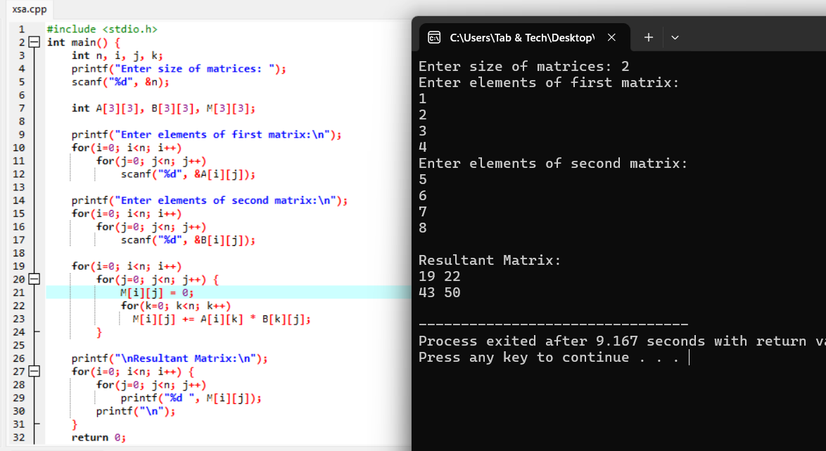

TASK 8:
#include <stdio.h>

int main() {
int a[3][3];
int i, j, even=0, odd=0, pos=0, neg=0, zero=0;
printf("Enter value of matrix :\n");
for(i=0; i<3; i++)
for(j=0; j<3; j++)
scanf("%d", &a[i][j]);

for(i=0; i<3; i++)
for(j=0; j<3; j++) {
if(a[i][j] % 2 == 0) even++;
else odd++;
if(a[i][j] > 0) pos++;
else if(a[i][j] < 0) neg++;
else zero++;
}
printf("\nMatrix even number is: %d\n", even);
printf("Matrix odd number are: %d\n", odd);
printf("Positive value count is: %d\n", pos);
printf("Negative value count is: %d\n", neg);
printf("And zero value are: %d\n", zero);

return 0;
}
OUTPUT:
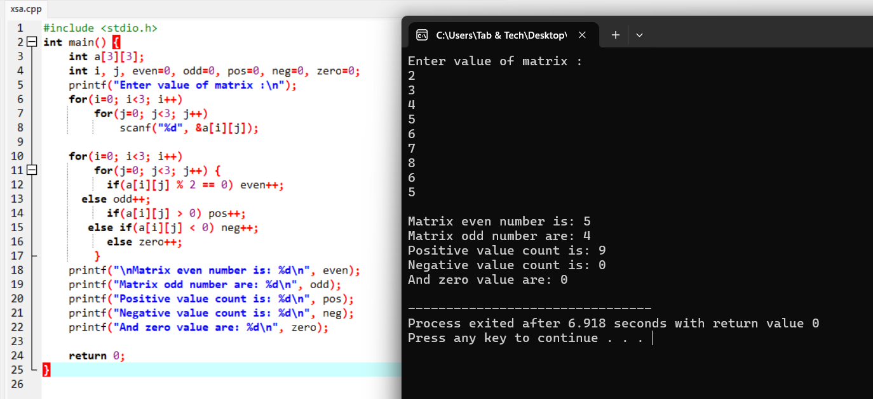

TASK 9:
#include <stdio.h>
int main() {
int a[3][3], t[3][3], rot[3][3];
int i, j;
printf("Enter matrix value :\n");
for(i=0; i<3; i++)
for(j=0; j<3; j++)
scanf("%d", &a[i][j]);

for(i=0; i<3; i++)
for(j=0; j<3; j++)
t[j][i] = a[i][j];

for(i=0; i<3; i++)
for(j=0; j<3; j++)
rot[i][j] = t[i][2-j];

printf("\nMatrix after rotate 90 degree is:\n");
for(i=0; i<3; i++) {
for(j=0; j<3; j++)
printf("%d ", rot[i][j]);
printf("\n");
}
return 0;
}

OUTPUT:
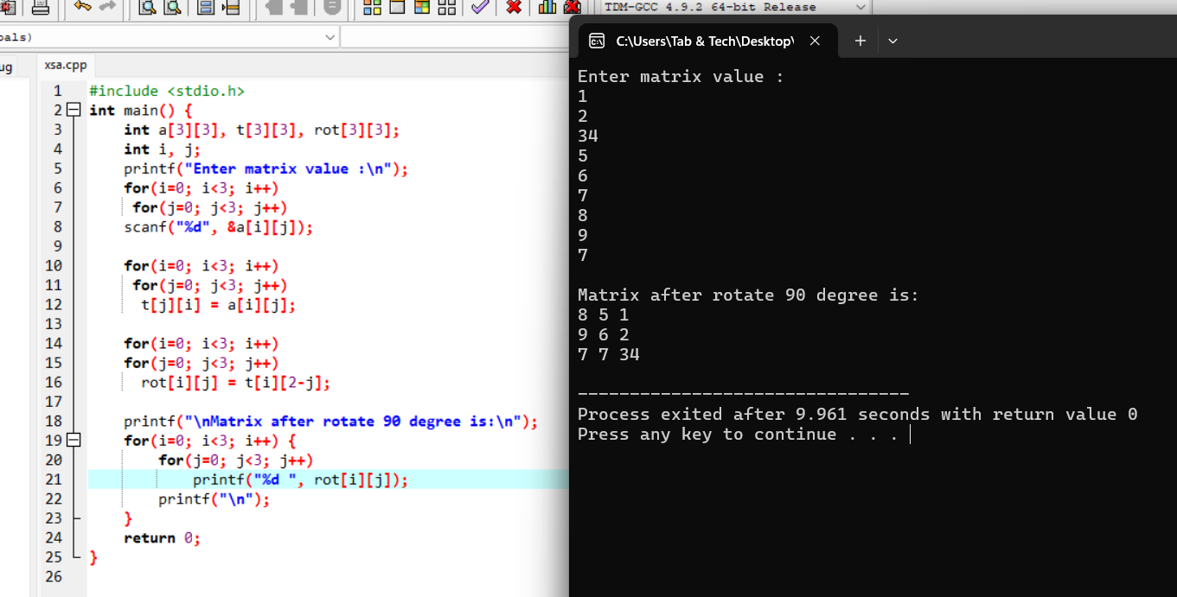

TASK 10:
#include <stdio.h>
int fact(int n) {
int f=1, i;
for(i=1; i<=n; i++)
f *= i;
return f;
}
int main() {
int n, i, j, num;
printf("Enter row number for pascal triangle: ");
scanf("%d", &n);

for(i=0; i<n; i++) {
for(j=0; j<=n-i; j++)
printf(" ");
for(j=0; j<=i; j++) {
num = fact(i)/(fact(j)*fact(i-j));
printf("%d ", num);
}
printf("\n");
}
printf("\nPascal triangle is printed succesfully\n");
return 0;
}

OUTPUT:
